Uno moo  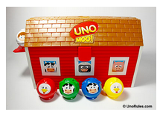  Basic Level  Ages: Pre-K-3rd grade | Pieces included in visuals  Rules for game  - Start by giving each person playing 5 animals, and a fence to hide them behind  - Place an animal on the barn door  - The first person will prompt the student using the visuals “Do you have a ____ or______?  - The student can answer Yes/no  - If they answer yes, then the student places either a matching animal or a matching color on the barn door knocking the one already up there inside the barn  - Continue to play until all of one person’s pieces are gone  Note:  - If the student does not have a color match or animal, they can draw from the barn  - Skunks are skips  - Farmers are wilds (any color can be played)  Additional Tips and Ideas  - Using the visuals prompt the student to ask peers “Do you have a ____or _____?

